**CSE 423 Final Suggestion**

1. Define a homogeneous coordinate system. Why does computer-graphics prefer a homogeneous coordinate system?
2. Make a simple classification tree of transformations/motions.
3. Derive |4x4| rotation matrix for a 3D point rotation across Y-axis and the center of rotation is (a, b, c).
4. Derive |4x4| rotation matrix for a 3D point rotation across X-axis and the center of rotation is (a, b, c).
5. Derive |4x4| rotation matrix for a 3D point rotation across Z-axis and the center of rotation is (a, b, c).
6. Derive |3x3| transformation matrix for reflection about any line L.
7. Determine the coordinate of a 3D point P(100, -60, 80) after rotating 600 across Y-axis, given that the center of rotation is (50, 20, 45).
8. Determine the coordinate of a 3D point P(100, -60, 80) after rotating 600 across X-axis, given that the center of rotation is (50, 20, 45).
9. Determine the coordinate of a 3D point P(100, -60, 80) after rotating 600 across Z-axis, given that the center of rotation is (50, 20, 45).
10. Find the following composite transformation matrices as instructed:
    1. A 3D rotation of 90 degree clockwise about y-axis with respect to the point (a, b, c) followed by a translation of (a, b, c).
    2. A reflection about the line ax - by + c = 0 followed by a scaling “e” times with respect to the point (a, b).
    3. A 3D rotation of 45 degree counterclockwise about z-axis with respect to point (d, e, f) followed by a uniform scaling of factor 3 with respect to point (d, e, f) and lastly followed by a translation of (a, b, c).

[Here a,b,c,d,e,f are arbitrary values]

1. Make a simple classification tree of projections.
2. Derive 4x4 simple purpose perspective projection matrix using appropriate figure, showing P, P′, COP, PP. Also, show that this matrix can be converted into simple perspective projection matrices. Possible cases are (i)Origin is at COP and (ii)Origin on the projection-plane.
3. Derive 4x4 general purpose perspective projection matrix using appropriate figure, showing P, P′, COP, PP.
4. Let a 3D point (423, -423, 423) be projected on a projection plane. Given that the center of the projection plane is (0.0, 0.0, -423.0) and the coordinate of the COP is (4, 2, 3). Determine the coordinate of that 3D point on the projection plane using a general purpose perspective projection matrix.
5. A 3D vertex P(40.0, 30.0, 20.0) is projected on the projection plane. Determine the projected coordinate P’ on the projection plane using the following projection matrix:

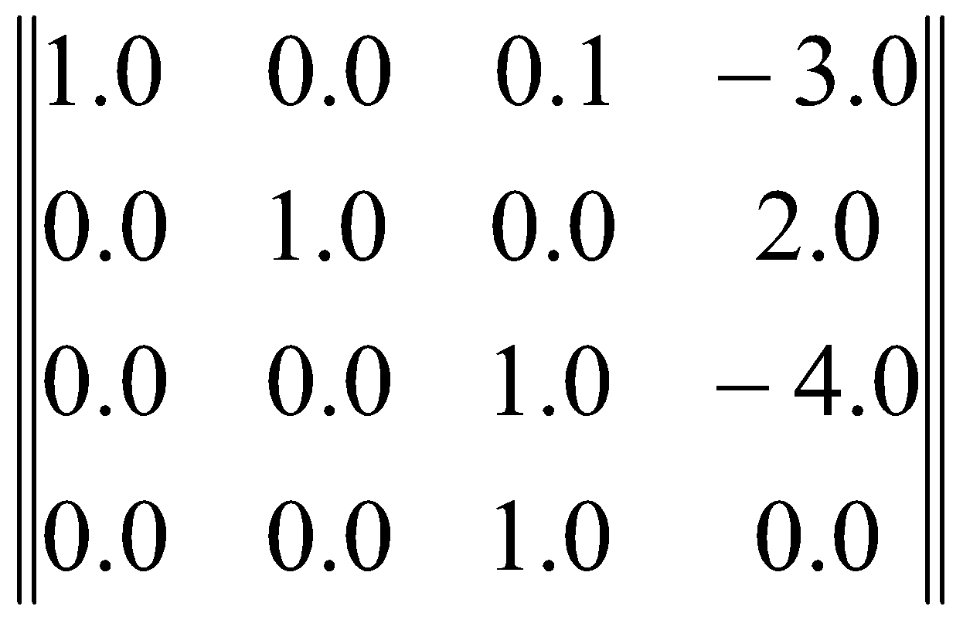

1. Make a comparison between Local light model and Global light model.
2. Make a comparison between Phong-shading and Gouraud-shading.
3. Write a complete equation for the local light model, showing all-components.
4. Explain diffuse reflection model and give a real-life example of only diffuse reflection.
5. Explain specular reflection model and give a real-life example of only specular reflection.
6. Explain Light Source attenuation.
7. Let (50, 70, 1500) be the coordinate of a light source of intensity 0.95 units. The light is illuminating a quad consisting of P0(10, 10, 5), P1(-10, 10, 5), P2(-10, -10, 6) and P3(10, -10, 6) vertices. Determine the intensity of the reflected light at the center of the quad using diffuse reflection model. Given that the diffuse absorption coefficient of the quad surface is 0.8 unit.
8. Let (50, 70, 1500) be the coordinate of a light source of intensity 0.95 units. The light is illuminating a sphere whose center is at C(10, -15, 6). Determine the intensity of the reflected light from a point P(20, 10, 120) on the sphere using a diffuse reflection model. Given that the diffuse absorption coefficient of the quad surface is 0.8 unit.
9. Make a comparison between additive and subtractive color models.
10. Draw RGB and CMY color cube.
11. Draw RGB and CMY color cube. Also, make a distinction between CMY and CMYK
12. Explain HLS/HSL Color Model using proper figures.
13. Write an algorithm for converting the RGB color values into HLS/HSL color values.
14. Write an algorithm for converting the RGB color values into HSV/HSB color values.
15. Convert the RGB colors into HLS/HSL color values.

(i) (0.25, 0.3, 1.0) (ii) (0.01, 1.0, 0.09) (iii) (0.8, 0.8, 0.35) (iv) (0,0, 0,4, 0.4)

(v) (1.0, 1.0, 0.5) (vi) (0.7, 0.71, 0.7) (vii) (0.5, 0.5 , 0.5) (viii) (1,0, 1,0, 1.0)

1. To answer some of the following questions, you will need four variables A, B, C and D which are sequentially the first, second, third and fourth pair of digits from the left in your student ID.

For example, if your ID is 15101208, then A= 15, B= 10, C= 12 and D= 8.

1. A color is given in CMY form with the values (0.A, 0.C, 0.D). Convert the color into an equivalent HSV model. Show the calculation in detail.
2. The color at vertex A is value B of your student ID and at vertex C is D of your student ID. Now calculate the color at point X using Gouraud shading. Can a specular light on point X be captured using the above model? Why or why not?

**